*A report on Internship*

# Google Android Developer Virtual Internship

*Submitted in partial fulfillment of the requirements For the award of the degree of*

## BACHELOR OF TECHNOLOGY

*in*

## Computer Science & Engineering

*by*

### Sushmitha C (204G1A05A6)



**Department of Computer Science & Engineering**



# 2023-2024



### Department of Computer Science & Engineering



Certificate

This is to certify that the internship report entitled Google Android Developer Virtual Internship is the bonafide work carried out by **Sushmitha Chinthakunta** bearing Roll Number 204G1A05A6 in partial fulfillment of the requirements for the award of the degree of **Bachelor of Technology** in **Computer Science and Engineering** for three months from January 2024 to March 2024.

**Internship Coordinator Head of the Department**

Mr. K. Lokeshnath MTech., (Ph.D) Mr. P. Veera Prakash M.Tech, (Ph.D)

Assistant Professor Assistant Professor

Date: **EXTERNAL EXAMINER**

Place: Anantapuramu

### PREFACE

All India Council for Technical Education (AICTE) has initiated various activities for promoting industrial internship at the graduate level in technical institutes and Eduskills is a Non-profit organization which enables Industry 4.0 ready digital workforce in India. The vision of the organization is to fill the gap between Academic and Industry by ensuring world class curriculum access to the faculties and students. Formation of the All-India Council for Technical Education (AICTE) in1945by the Government of India.

**Purpose:** With a vision to create an industry-ready workforce who will eventually become leaders in emerging technologies, EduSkills & AICTE launches ‘Virtual Internship’ program on Android Technology, supported by Google.

**Company’s Mission Statement:** The main mission of these initiatives is enhancement of the employability skills of the students passing out from Technical Institutions.

**ACKNOWLEDGEMENT**

The satisfaction and euphoria that accompany the successful completion of any task would be in complete without the mention of people who made it possible, whose constant guidance and encouragement crowned our efforts with success. It is a pleasant aspect that I have now the opportunity to express my gratitude for all of them.

It is with immense pleasure that I would like to express my in debted gratitude to my internship coordinator **Mr. K. Lokeshnath, M.Tech, (Ph.D), Assistant Professor, Computer Science and Engineering** who has supported me a lot and encouraged me in every step of the internship work. I thank him for the stimulating support, constant encouragement and constructive criticism which have made possible to bring out this internship work.

I am very much thankful to **Mr. P. Veera Prakash, M.Tech, (Ph.D), Assistant Professor and Head of the Department, Computer Science and Engineering,** for his kind support and for providing necessary facilities to carry out the work.

I wish to convey my special thanks to **Dr. G. Balakrishna, M.Tech, Ph.D, Principal** of **Srinivasa Ramanujan Institute of Technology** for giving the required information in doing my internship. Not to forget, I thank all other faculty and non- teaching staff, and my friends who had directly or indirectly helped and supported me in completing my internship in time.

I also express our sincere thanks to the Management for providing excellent facilities and support**.**

Finally, I wish to convey my gratitude to my family who fostered all the requirements and facilities that I need.

**Sushmitha Chinthakunta**

**(204G1A05A6)**

|  |  |  |
| --- | --- | --- |
| **Chapter No.** | **Contents** | **Page No.** |
| **List of Figures** | | vi |
| **List of Abbreviations** | | vii |
| Chapter 1: | Introduction | 1 |
| Chapter 2: | Technology | 2 |
| Chapter 3: | Applications | 4 |
| Chapter 4: | Modules Explanation | 6 |
| Chapter 5: | Real time Examples | 17 |
| Chapter 6: | Learning outcomes | 19 |
| Conclusion | | 20 |
| Internship certificate | | 21 |
| References | | 22 |
|  | | |

**LIST OF FIGURES**

vi

|  |  |  |  |
| --- | --- | --- | --- |
| **Figure No.** | **Figure Name** | | **Page No.** |
| 4.1 | Setting up android studio | | 13 |
| 4.2 | Building calculator using button widget | | 14 |
| 4.3 | Material Design | | 15 |
| 4.4 | Jetpack Compose | | 17 |
| 4.5 | Connect to the Internet | | 19 |
| 4.6 | Types of SQL Commands | | 21 |
| 4.7 | Different Views in Android | | 23 |
| 5.1 | Use Cases of Android | | 24 |
|  |  | |  |
|  |  |
|  |  |
|  |  |
|  |  |
|  |  |

**LIST OF ABBREVIATIONS**

vii

|  |  |
| --- | --- |
| API | Application Programming Interface |
| URL | Uniform Resource Locator |
| SDK | Software Development Kit |
| SQL | Structured Query Language |
| XML | Extensible Markup Language |
| JDK | Java Development Kit |
| IDE | Integrated Development Environment |
| UI | User Interface |
| HTTP | Hyper Text Transfer Protocol |
|  |  |

# CHAPTER 1

**INTRODUCTION**

Launched by Google in 2008, Android is an open-source operating system based on the Linux kernel that encourages community collaboration for continuous improvement. It is a flexible platform that works with a variety of devices because of its adaptability and versatility.

Google Central to Android's development is Google, offering core software, services, and updates. The Google Play Store serves as the official app distribution platform, granting users access to millions of applications. The user interface of Android is tailored for touch gestures, featuring a customizable home screen and support for widgets, ensuring an interactive and intuitive experience.

For application development on Android, the primary programming languages are Java and Kotlin. The Android Software Development Kit (SDK) provides the tools needed for app creation, leveraging a comprehensive set of APIs. The app ecosystem is diverse, covering categories from games and productivity tools to social media and entertainment apps.

Android prioritizes user customization, offering options such as changing wallpapers, themes, and utilizing different launchers. Advanced users can even root their devices to gain deeper access and control over the operating system. Security is a focal point for Android, incorporating features like app sandboxing, regular security updates, and permissions management to safeguard user data.

Regular updates are a hallmark of Android, introducing new features, improvements, and security patches. Notably, each major Android version is named after a dessert or sweet treat, following an alphabetical order. This nomenclature adds a whimsical touch to the platform.

In essence, Android's adaptability, extensive app ecosystem, commitment to regular updates, and playful nomenclature contribute to its widespread popularity in the ever-evolving realm of mobile technology. Its open nature continues to foster innovation and collaboration within the developer community.

# CHAPTER 2

**TECHNOLOGY**

Android, as an operating system for mobile devices, employs a variety of technologies to provide a robust and versatile platform. To excel in an Android development role, you'll need a combination of technical skills, soft skills, and a good understanding of the Android ecosystem. Here are the key skills that can help you succeed in an Android role:

#### Programming Languages (Java and Kotlin)

A solid grasp of Java is foundational for Android development. Kotlin, introduced by JetBrains, is now officially supported by Google and is increasingly favored for its conciseness, expressiveness, and safety features. Proficiency in both languages allows you to leverage their strengths based on project requirements.

#### Android SDK and API’s

In-depth knowledge of the Android Software Development Kit (SDK) and understanding how to work with Android APIs is crucial. This includes expertise in UI components, data storage (Shared Preferences, SQLite, or Room), and utilizing features like notifications and permissions.

#### Android Studio

Android Studio is the official Integrated Development Environment (IDE) for Android development. A thorough understanding of Android Studio's features, including debugging tools, profilers, and the layout editor, is essential for efficient coding and debugging.

#### XML (Extensible Markup Language)

Android uses XML for defining layouts and UI elements. A developer should be proficient in creating and understanding XML layouts to design visually appealing and responsive user interfaces.

#### Version control/git

Git is a widely used version control system in collaborative software development. Proficiency in Git, including branching, merging, and conflict resolution, is crucial for effective collaboration and code management.

#### Gradle build system

Android projects rely on the Gradle build system. Understanding how to configure build scripts, manage dependencies, and optimize build processes ensures smooth development workflows and efficient app builds.

#### Database Management

Android developers should be proficient in working with databases, especially SQLite, and understand data storage options like Room Persistence Library. This skill is vital for managing and retrieving data efficiently in Android applications.

#### Communication and collaboration

Effective communication is vital, especially when working in a team. Clear expression of ideas, providing constructive feedback, and collaborating with other developers, designers, and stakeholders contribute to a positive and productive team environment.

**CHAPTER 3 APPLICATIONS**

### Android development is a form of software engineering dedicated specifically to creating applications for devices that run on the Android platform. Some of the uses cases of Android Development are-

1. **Real-Time Messaging Apps:**
   * Description: Apps like WhatsApp or Telegram provide instant messaging, where users can send and receive messages in real-time.
   * Key Characteristics:
     + Instant message delivery
     + Real-time presence status
     + Push notifications for new messages
2. **Live Streaming Apps:**
   * Description: Platforms like YouTube or Twitch allow users to broadcast and watch live streams.
   * Key Characteristics:
     + Low-latency streaming
     + Real-time viewer interaction (comments, likes)
     + Live updates on concurrent viewers
3. **Collaborative Editing Apps:**
   * Description: Applications like Google Docs enable real-time collaboration on documents.
   * Key Characteristics:
     + Simultaneous editing by multiple users
     + Real-time updates on changes
     + Version history tracking
4. **Real-Time Navigation Apps:**
   * Description: Navigation apps like Google Maps provide real-time updates on traffic conditions and route changes.
   * Key Characteristics:
     + Real-time GPS tracking
     + Dynamic route adjustments based on traffic
5. **Live Score Apps:**
   * Description: Sports apps like ESPN or Score provide real-time updates on live sports events.
   * Key Characteristics:
     + Instant score updates
     + Real-time statistics
     + Live commentary
6. **Real-Time Collaboration Tools:**
   * Description: Apps like Slack or Microsoft Teams facilitate real-time communication and collaboration within teams.
   * Key Characteristics:
     + Instant messaging and file sharing
     + Real-time status updates
     + Notification alerts
7. **Financial Trading Apps:**
   * Description: Trading platforms like Robinhood or E*TRADE require real-time updates on stock prices and trade execution.
   * Key Characteristics:
     + Real-time market data
     + Instant order execution
     + Live portfolio updates
8. **Real-Time Gaming Apps:**
   * Description: Multiplayer games like PUBG Mobile or Among Us involve real-time interactions between players.
   * Key Characteristics:
     + Low-latency gameplay
     + Real-time chat and voice communication
     + Synchronized game events

**CHAPTER 4**

**MODULE EXPLANATION**

**Module-1: Your first Android app**

The module describes about the android and requirements of android. The requirements include Kotlin programming language, setting up the android studio and describes building a basic layout.

Kotlin, a modern and concise programming language, has emerged as a preferred choice for Android app development. Endorsed by Google, Kotlin offers a seamless integration with existing Java code and brings a host of features like null safety, concise syntax, and improved code readability. Its expressive and pragmatic nature accelerates development, making it an excellent fit for Android projects. As the official language for Android app development since 2017, Kotlin enhances developer productivity, reduces boilerplate code, and contributes to building robust, efficient, and more maintainable Android applications.

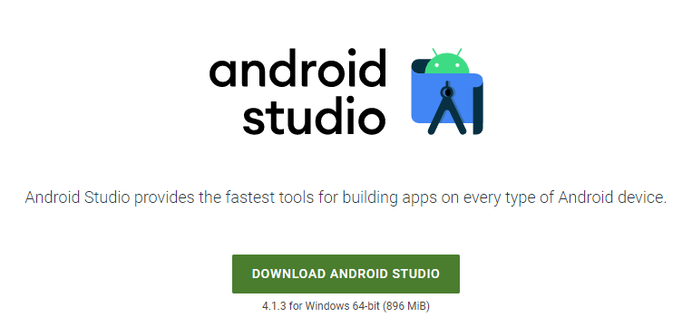

**Fig:4.1 Setting up android studio**

**Android Studio Installation and Configuration of SDK & JDK**

**JDK download:**

https://www.oracle.com/java/technologies/downloads/#jdk17-windows

**IDE download**:

https://developer.android.com/studioOperations Perspective

### Module 2: Building app UI

This module offers an overview of fundamentals of Kotlin, widgets in android studio, and interacting with UI.

The fundamentals of Kotlin encompass key features of the modern and concise programming language, including robust support for object-oriented programming (OOP) principles. Kotlin seamlessly integrates with existing Java code, providing features like null safety, concise syntax, and improved code readability. Object-oriented programming principles such as encapsulation, inheritance, and polymorphism are foundational concepts in Kotlin, enabling developers to create modular and maintainable code structures. Additionally, Kotlin introduces the concept of lambdas, allowing for concise and expressive functional programming. Lambdas facilitate the creation of anonymous functions, enhancing code conciseness and promoting a more functional programming style within the Kotlin language.

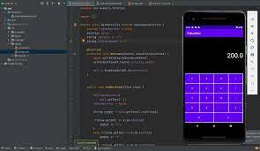

**Fig:4.2 Building calculator using button widget**

Embarking on the exploration of UI interaction and state management, we delve into the development of a tip calculator app. The app is designed to compute tips based on user input, demonstrating fundamental principles of user interface design and state management. Throughout the development process, we explore techniques for capturing user input, dynamically updating the UI, and managing the application's state to ensure a seamless and responsive user experience. By the end of this module, learners will have gained valuable insights into creating interactive UIs and handling states, providing a solid foundation for developing user-friendly applications.

## Module 3: Display lists and use Material Design

Commencing with a succinct overview, this encapsulation outlines key Kotlin programming concepts vital for developers aspiring to craft lively and engaging Android applications.

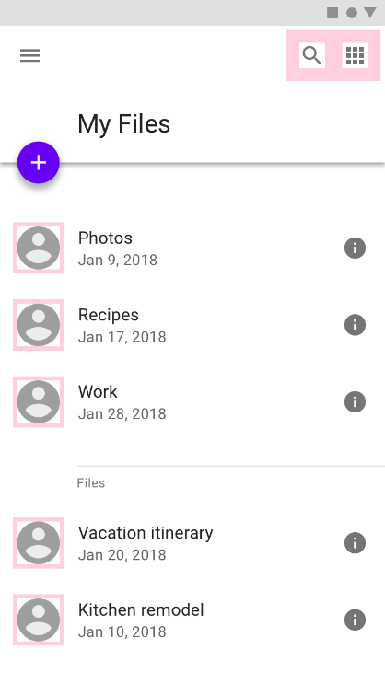From Kotlin's clean and readable syntax to its support for asynchronous programming through coroutines, these concepts empower developers to build responsive, efficient, and feature-rich apps. The language's seamless interoperability with Java, coupled with advanced features like extension functions and higher-order functions, promotes expressive coding styles, enhancing the overall development experience. Additionally, Kotlin's robust type system and support for null safety contribute to more reliable code, fostering a foundation for creating sophisticated and enjoyable Android applications.

**Fig:4.3 Material Design**

In this module, we explore the creation of an app using Compose that showcases a scrollable list containing both text and images. By following the provided guidelines, developers will gain hands-on experience in leveraging Compose, a modern Android UI toolkit, to design and implement dynamic interfaces. The app's functionality includes the seamless integration of text and images within a scrollable layout, demonstrating essential techniques for creating engaging and visually appealing user experiences. This documentation serves as a valuable resource for developers seeking insights into building versatile and interactive applications through Compose.

Elevate the visual appeal and user experience of your applications by incorporating Material Design principles, animations, and accessibility best practices. This documentation pro vides valuable insights into creating more beautiful and intuitive apps. Material Design ensures a consistent and polished appearance, while animations add a dynamic touch to interactions, enhancing engagement. Following accessibility best practices ensures inclusivity for diverse users. Developers will find this guide essential for implementing these design elements, contributing to the overall aesthetic and usability of their applications.

## Module 4: Navigation and app architecture

This module gives knowledge about developers in harnessing the power of the Navigation component to construct intricate Android applications with multiple screens. Learn the art of seamless navigation between different composable while efficiently passing data between screens. By delving into this module, developers will acquire the skills to architect more complex and interconnected apps, enhancing user experiences through intuitive and well-organized navigation flows. Mastering the Navigation component's capabilities ensures a streamlined approach to handling diverse app architectures, fostering the development of dynamic and feature-rich applications.

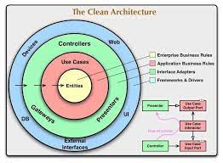Efficiently adapt your app to diverse screen sizes and elevate user experiences with this comprehensive documentation. Explore strategies for responsive design that optimize your application's visual appeal across various devices. Gain practical insights into testing and refining your adaptive UI, ensuring seamless interactions for users on different screen dimensions. This guide empowers developers to create versatile applications that dynamically respond to the unique characteristics of various screen sizes, delivering an enhanced and consistent user experience.

**Fig:4.4 Jetpack compose**

Embark on a comprehensive exploration of the Navigation component through this detailed documentation, designed to empower developers in constructing sophisticated Android applications featuring multiple screens. Delving into intricate strategies for seamless navigation between diverse composable, the module provides nuanced insights into the hierarchical structure and design principles conducive to an integrated user journey. Additionally, developers will gain profound knowledge on the effective passing and management of data between screens, emphasizing efficiency and maintaining a resilient architecture. This resource is tailored to help developers master the advanced functionalities of the Navigation component, enabling the creation of dynamic, interconnected applications that respond dynamically to user interactions.

## Module 5: Connect to the internet

Connecting to the internet is a fundamental aspect of modern application development, enabling communication between devices and servers. Here's a concise overview of key concepts when establishing internet connections in software:

**Network Permission:** Declare the necessary network permissions in the AndroidManifest.xml file. This is crucial for the app to access the internet. You typically include the <uses-permission> element with appropriate permissions like <uses-permission android:name="android.permission.INTERNET"/>. This permission allows the app to create network sockets for sending and receiving data over the internet.

**Network Requests:** Use either HTTP or HTTPS protocols to initiate network requests from your application to remote servers. This is typically done using the following methods:

* **HttpURLConnection:** This is a basic API provided by Java for sending HTTP requests and receiving responses. It's relatively low-level but offers fine-grained control over the request and response process.
* **HttpClient:** Historically, HttpClient was a commonly used library for sending HTTP requests. However, it has been deprecated in recent Android versions in favor of newer and more efficient APIs like HttpURLConnection or third-party libraries like OkHttp.

**Third-party Libraries:** Consider using third-party libraries like OkHttp, Retrofit, or Volley for making network requests. These libraries provide higher-level abstractions, better performance, and more features compared to the basic HTTP APIs provided by Android.

**Get data from internet**

To fetch data from the internet in an Android application, you need to ensure that your app has the necessary network permissions declared in the AndroidManifest.xml file. This is crucial for the app to access the internet. Once permissions are set, you can initiate network requests using HTTP or HTTPS protocols. Common methods include HttpURLConnection, which is a basic API provided by Java, or third-party libraries like OkHttp. It's essential to execute network operations asynchronously to prevent blocking the main UI thread, which could lead to an unresponsive user interface. Additionally, implement proper error handling mechanisms to gracefully manage network errors and ensure a smooth user experience.

In Android application development, fetching data from the internet involves a multi-step process that ensures smooth and reliable communication between your app and remote servers. To begin with, it's essential to declare the necessary network permissions in your AndroidManifest.xml file. Without these permissions, your app won't be able to access the internet. You typically include the <uses-permission> element with the android.permission.INTERNET permission, granting your app the ability to create network sockets for sending and receiving data over the internet.

Once the permissions are set, you can initiate network requests using HTTP or HTTPS protocols. The most common methods for making network requests in Android are through the use of HttpURLConnection or third-party libraries like OkHttp. HttpURLConnection provides a basic API for sending HTTP requests and receiving responses. While it offers fine-grained control over the request and response process, it can be somewhat low-level. Alternatively, OkHttp is a widely-used third-party library that offers a more modern and efficient API compared to HttpURLConnection.

When making network requests, it's crucial to perform these operations asynchronously. This means executing network tasks in the background to prevent blocking the main UI thread. Blocking the UI thread can lead to an unresponsive user interface and result in a poor user experience. Asynchronous execution can be achieved using various techniques such as AsyncTask, Handlers, Threads, or Kotlin coroutines. These mechanisms allow you to perform network operations in the background while keeping the UI responsive.

Furthermore, proper error handling is essential when dealing with network requests. Network operations are inherently unpredictable and can fail due to various reasons such as network connectivity issues, server errors, or timeouts. Therefore, it's crucial to implement error handling mechanisms to gracefully manage these situations. This may include implementing retry policies, setting timeouts, and displaying appropriate error messages to the user. By handling errors effectively, you can enhance the reliability of your app and provide a smoother user experience.

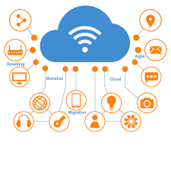

**Fig:4.5 Connect to the Internet**

## Module 6: Data persistence

## Data persistence in software development refers to the process of storing and retrieving data to and from a persistent storage medium, such as a database or file system. It is a crucial aspect of creating robust and user-friendly applications. There are several methods for achieving data persistence in Android applications:

## Shared Preferences: This is the simplest way to store small amounts of primitive data in key-value pairs. Shared Preferences are ideal for storing user preferences or settings.

## Internal Storage: You can store private data files directly on the device's internal storage. These files are accessible only by your application and are not shared with other applications.

## External Storage: This method allows you to save files on the device's external storage, such as an SD card. This data is accessible by other applications and users, so it's important to properly manage permissions and handle security concerns.

## SQLite Databases: Android provides built-in support for SQLite databases, which offer a robust way to store structured data in a relational database format. SQLite databases are suitable for managing large datasets and performing complex queries.

## Room Persistence Library: Room is a SQLite object mapping library provided by the Android Architecture Components. It simplifies working with SQLite databases by providing an abstraction layer and compile-time checks for SQL queries.

## Network Storage: You can store data remotely on a server or cloud storage and retrieve it as needed by your application. This approach requires network connectivity and proper handling of data transfer and security.

**Databases:**

Databases are organized collections of structured information or data, typically stored electronically in a computer system. They serve as efficient and systematic ways to manage, organize, and retrieve data. Databases play a crucial role in various applications, ranging from small-scale projects to large enterprise systems. Key characteristics of databases include data integrity, security, and the ability to support concurrent access by multiple users.

**SQL (Structured Query Language):**

SQL, or Structured Query Language, is a powerful domain-specific language designed for managing and manipulating relational databases. It provides a standardized way to interact with databases, allowing users to perform operations such as querying, updating, inserting,

and deleting data. SQL is used to define and manipulate the structure of relational databases, create and modify tables, and retrieve information based on specified criteria.

## 14 Essential SQL Commands [2024] | SQL Commands List PDF

**Fig:4.6 Types of SQL Commands**

**Storing and Accessing Data Using Keys with DataStore**

## DataStore, a component of Android Jetpack, represents a contemporary approach to managing and persisting key-value pairs, introducing a more robust and type-safe alternative to the traditional SharedPreferences system. Operating on the foundational concept of key-value storage, DataStore ensures that each piece of data is associated with a unique identifier, facilitating straightforward retrieval and updates as needed. This system proves particularly advantageous for applications requiring efficient data management, such as storing app preferences or managing small datasets.

## Within the realm of DataStore, two distinct types are available to developers: Preferences DataStore and Proto DataStore. Preferences DataStore closely resembles SharedPreferences but offers enhanced functionality through typed keys, thereby simplifying the storage and retrieval process for straightforward key-value pairs. On the other hand, Proto DataStore stands out as the preferred option for handling more intricate data structures and objects. Leveraging Protocol Buffers for serialization, Proto DataStore empowers developers to store and manage structured data efficiently.

## One of the key strengths of DataStore lies in its seamless integration with Kotlin Coroutines, a feature that greatly simplifies asynchronous operations for storing and retrieving data. By leveraging coroutines, developers can execute these operations without blocking the main thread, thereby ensuring smooth and responsive user experiences.

## Module 7: WorkManager

Google's Android WorkManager is a powerful API within the Android Jetpack library designed to simplify and manage background tasks in Android applications. It addresses the need for executing tasks that continue running even when the app is not in the foreground or if the device restarts. Here's a brief summary of WorkManager's key features:

**Background Task Management:**

WorkManager allows developers to schedule and manage tasks that run in the background, such as data syncing, periodic updates, or content downloads.

**Persistent Execution:**

Tasks scheduled with WorkManager persist across device reboots and app closures, ensuring reliable execution even in challenging conditions.

**Simplified API:**

WorkManager provides a simplified and consistent API, abstracting away the complexity of managing background tasks. It is built on top of existing Android background job mechanisms, offering a unified approach.

**Flexible Scheduling:**

Developers can schedule tasks as one-time or periodic, offering flexibility based on the nature of the background work needed.

**Constraints Management:**

WorkManager allows the specification of constraints, such as network availability or battery status, to control when a task should be executed, optimizing resources and improving efficiency.

**Integration with Other Jetpack Components:**

It seamlessly integrates with other Android Jetpack components, facilitating the development of robust and modular applications.

**Debugging Tools:**

WorkManager comes equipped with a Background Task Inspector in Android Studio, providing tools for monitoring and debugging background tasks effectively during development.

**Result Handling:**

Developers can handle the results of background tasks using the Result object, allowing for proper handling of success, failure, or retry scenarios.

## Module 8: Views and Compose

A View is a fundamental element for any user interface (or design) in android. The View is a base class for all UI components in android. For example, the EditText class is used to accept the input from users in android apps, which is a subclass of View. Following are the some of common View subclasses that will be used in android applications.

* TextView
* EditText
* Button
* CheckBox
* RadioButton
* ImageButton

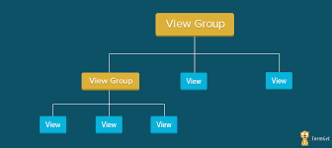

**Fig:4.7 Different Views in Android**

**CHAPTER 5**

**REAL TIME EXAMPLES**

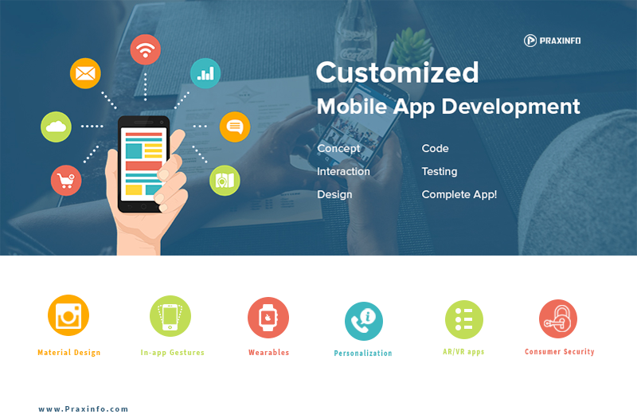Some top companies that use android in various use cases and industries such as business, healthcare and more. Some of the real time applications are:

**Fig:5.1 Use Cases of Android**

#### Ride-Sharing Apps (e.g., Uber, Lyft)

Users can request a ride and track the real-time location of their driver. The app provides continuous updates on the driver's location, estimated time of arrival, and the route taken.

#### Food Delivery Apps (e.g., DoorDash, Grubhub)

Customers can place orders for food delivery and receive real-time updates on the status of their order, including confirmation, preparation, and the delivery process.

#### Weather Apps with Real-Time Updates (e.g., AccuWeather)

Weather apps provide real-time updates on current weather conditions, forecasts, and alerts based on the user's location.

#### Home Security Apps with Live Camera Feeds (e.g., Nest, Ring)

Users can view live camera feeds of their home security cameras in real-time, receive alerts for motion detection, and even communicate with visitors through two-way audio.

#### Emergency Services Apps (e.g., SOS Apps)

Apps designed for emergencies can provide real-time location tracking and communication features. Users can send distress signals with their precise location to emergency contacts or services.

#### Health and Fitness Apps with GPS (e.g., Strava, Runkeeper)

Fitness apps utilize real-time GPS tracking to monitor and record users' routes, distances, and speeds during activities like running or cycling.

#### Instant Messaging Apps (e.g., WhatsApp, Telegram)

These apps facilitate real-time communication through instant messaging, supporting features like read receipts, typing indicators, and multimedia sharing.

#### Real-Time Language Translation Apps (e.g., Google Translate)

Apps that provide instant translation services, allowing users to translate spoken or written words in real-time.

#### Live Auction Apps (e.g., eBay)

Auction apps allow users to participate in real-time bidding on items, with immediate updates on the current highest bid and auction countdown.

#### Live Event Streaming Apps (e.g., Facebook Live, Instagram Live)

Users can broadcast live videos to their followers in real-time, and viewers can engage by sending comments and likes as the stream unfolds.

**CHAPTER 6**

**LEARNING OUTCOMES**

By the end of this we will be able to know about:

* + Gain an overall understanding of basic android.
  + Become familiar with shared preferences and layouts.
  + Learn the architectural principles of the android.
  + Understand and be able to explain android activities building apps.
  + Engage in hands-on practice to create apps.

**CONCLUSION**

Enrolling in Google's Android development course provides a concise yet comprehensive journey into the world of mobile app creation. With Google's expertise in developing the Android platform, learners can expect a focused curriculum covering essential topics like programming languages, the Android SDK, and API integration. The course's hands-on approach ensures a practical understanding of building robust applications, aligning with industry standards. Google's direct involvement assures access to up-to-date content, reflecting the latest trends and tools in Android development. Completing this course not only equips individuals with the skills necessary for app creation but also stands as a valuable endorsement from a leading authority in the mobile technology landscape.

**CERTIFICATE**

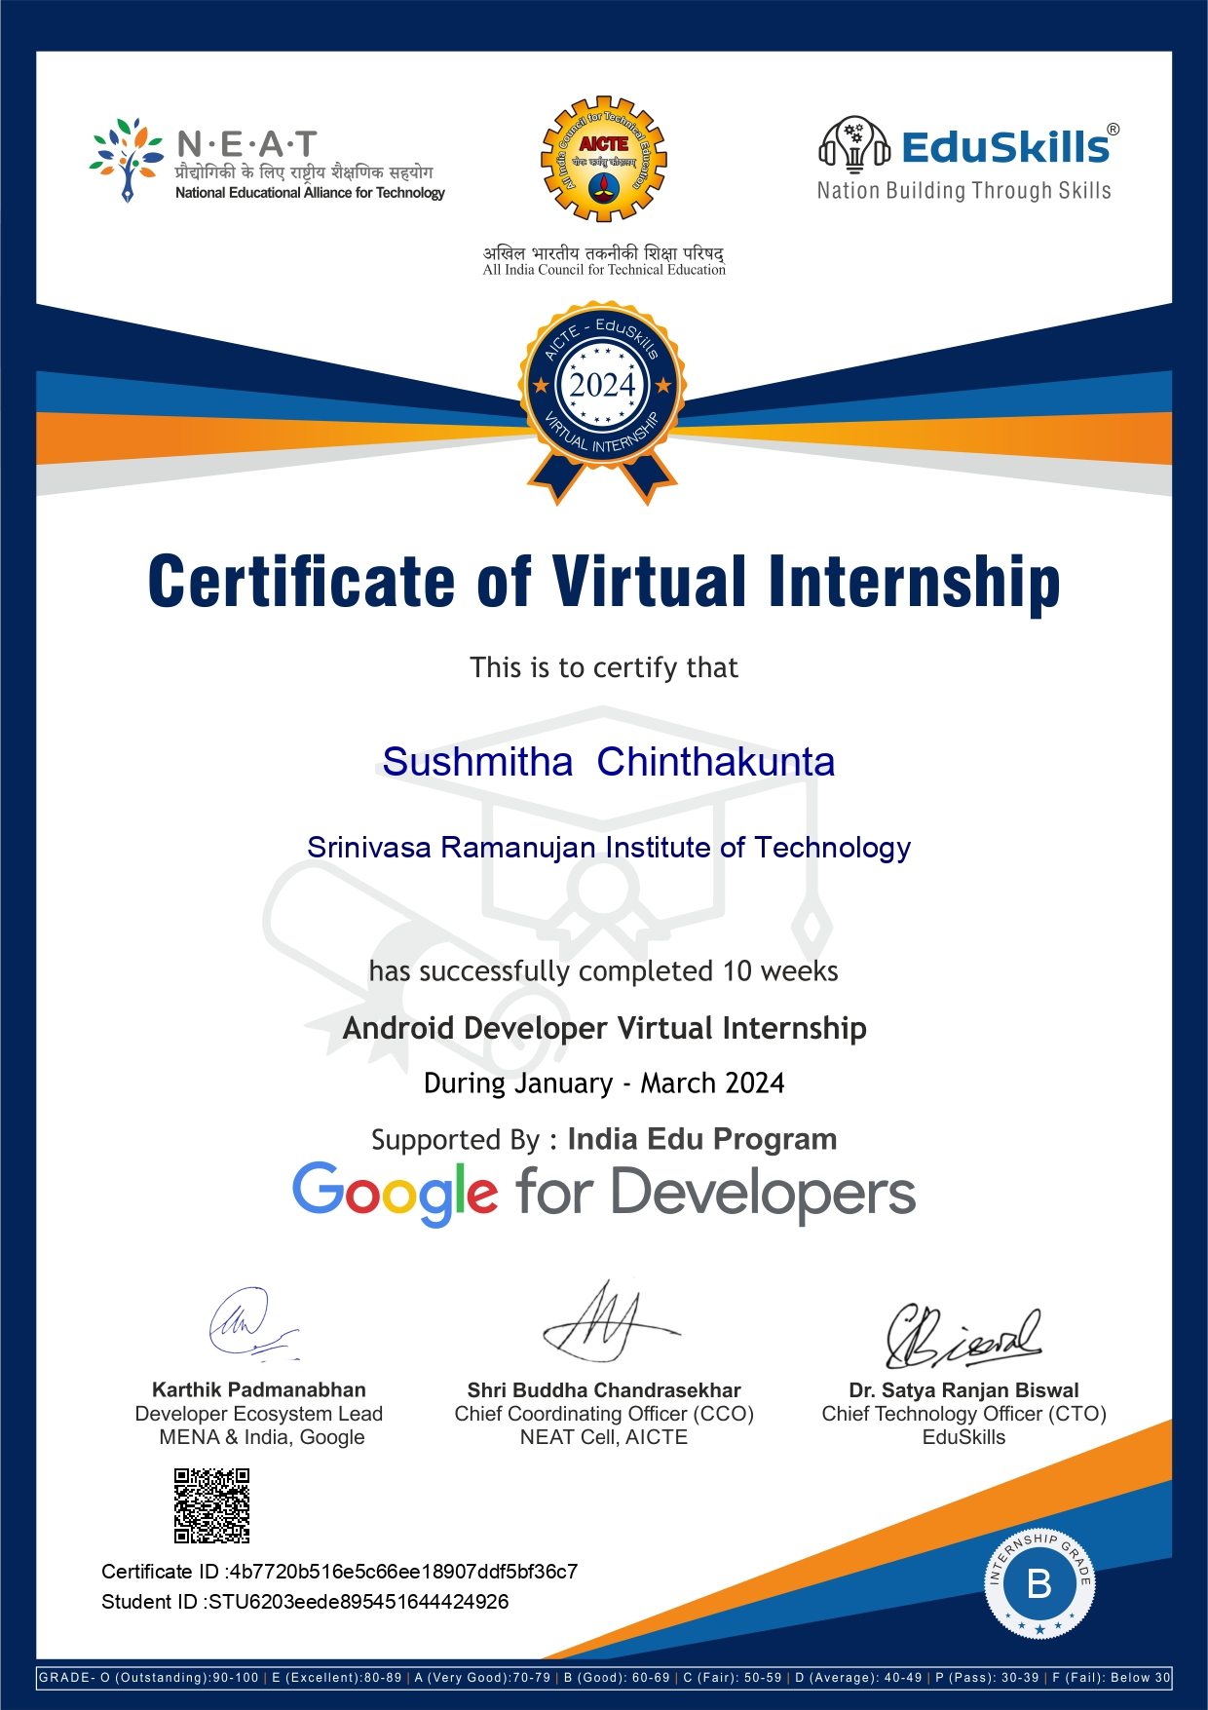

**REFERENCES**

[1] <https://developer.android.com/courses/android-basics-compose/course>

[2] [https://internship.aicte-india.org](https://internship.aicte-india.org/)